1. Create new repository in github as assessment

For an empty repository

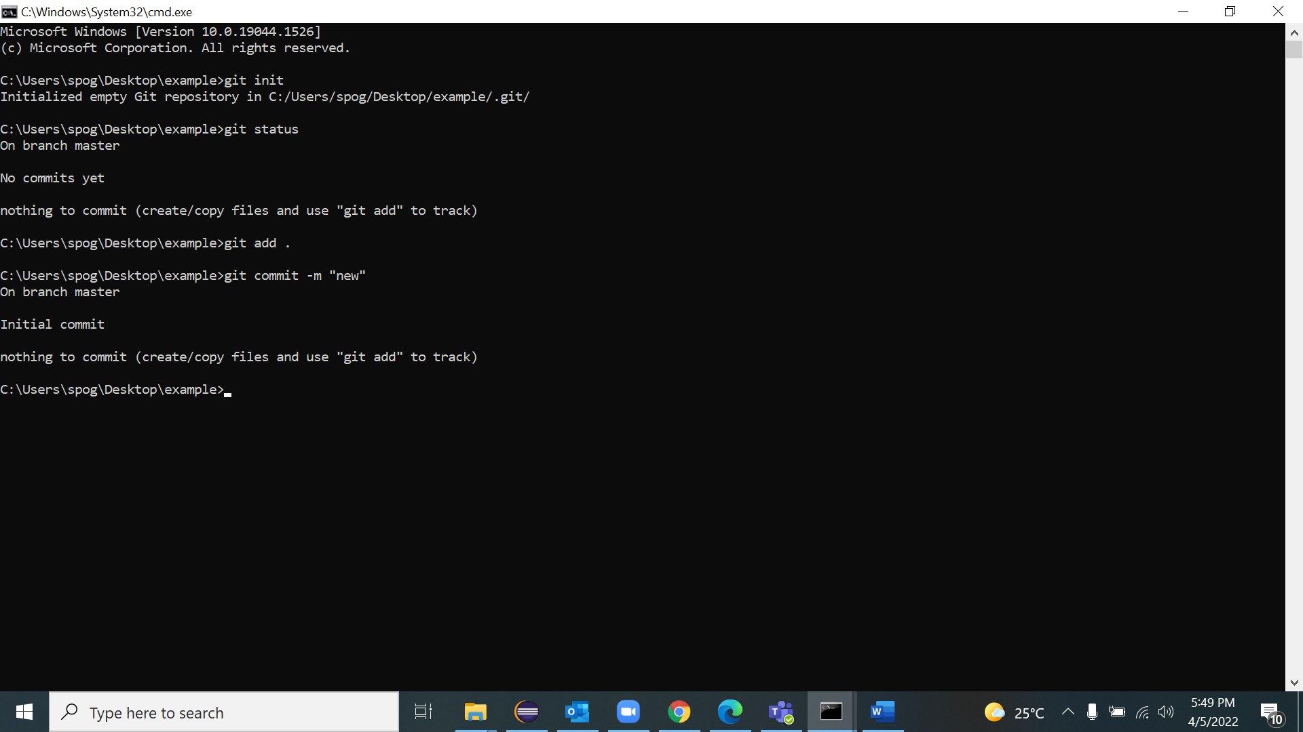

Click on + then new repository and repository should be public

1. A screenshot of a computer

   Description automatically generated
2. A screenshot of a computer

   Description automatically generated
3. Created new folder in local system and intialised git
4. git init
5. git add .
6. Git commit -m “test1 by Spoorthi”
7. git remote add origin <https://github.com/SpoorthiGirish/assesment.git>
8. git branch -M main
9. git push -u origin main
10. 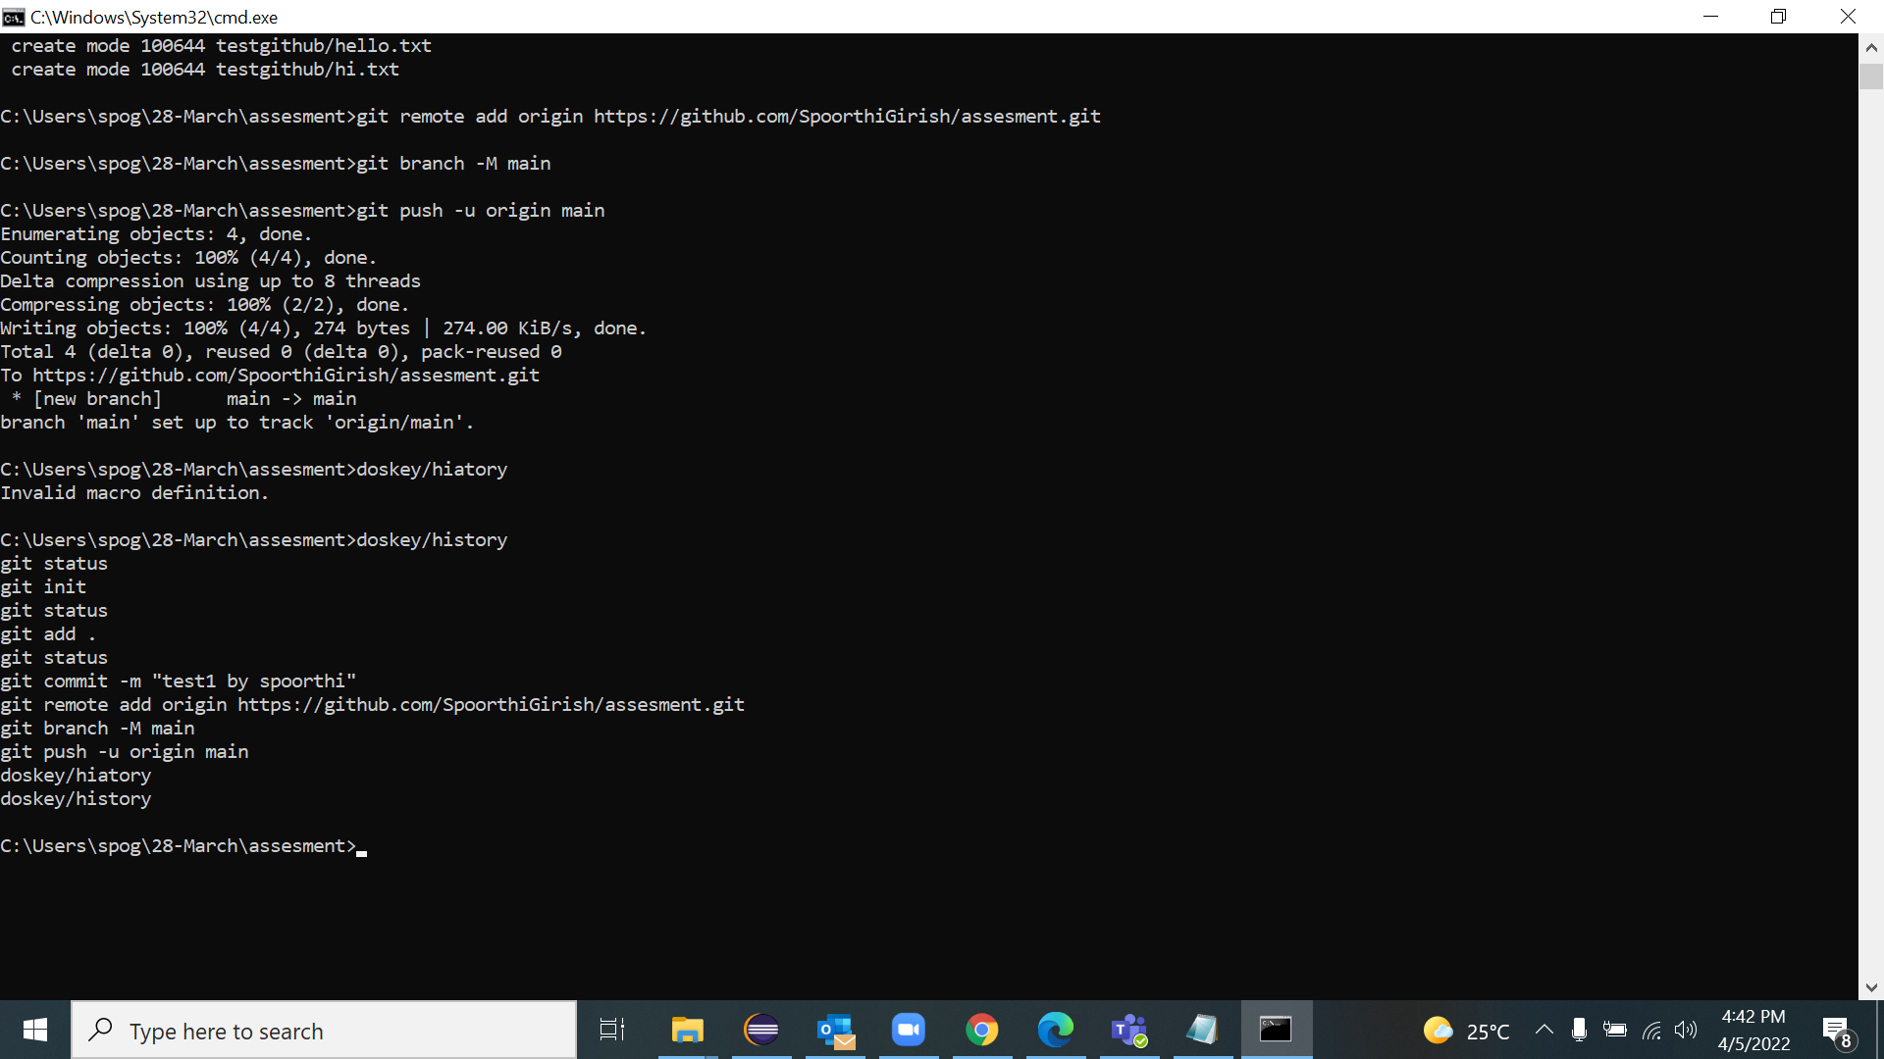Graphical user interface, application, table, Excel

    Description automatically generated

2. Create a simple java maven project which concatinate First name and last name and prints "Hello firstname lastname"

1.Created maven project from eclipse having jar as the package

2.created org as package inside maven project and created new class

**package** org;

**import** java.util.Scanner;

**public** **class** ConFirSec {

**public** **static** **void** main(String[] args) {

Scanner sc =**new** Scanner(System.***in***);

System.***out***.println("enter first name");

String a=sc.next();

System.***out***.println("enter last name");

String b=sc.next();

System.***out***.println("Hello " + a + " " + b);

}

}

3. run the code

3. Run the following command against the project.

- clean , compile, test, code coverage and build

1. Right click on project run as clean,compile,test.code coverage,build

4.

Add remote git hub repository.

1. Solution- git remote add origin <https://github.com/SpoorthiGirish/assesment.git>
2. git branch -M main
3. git push -u origin main
4. I have pushed the maven project to github

6. Create a jenkins job to execute the project from Jenkins interface

Go to new item – freestyle project , in execute windows batch command add the commands

Apply and save, build now

7. Run the Jenkins pipeline to successfully generate the build.

Create new item-pipeline project, in pipeline section add the sample hello world code

Apply and save

